**Assumptions:**   
  
1) A numerical rating of 1-5 is given for each experience (5 for an excellent experience an 1 for a poor experience)

- assume that rating will have no decimals

2) The host can also include a message to the guest in their offer.  
- assume guest has the ability to message; which means I assume that this message is not optional.

3) Q2e has no order

Q2a

|  |
| --- |
| SELECT DISTINCT date_format(B.visit_date, '%d/%m/%Y') AS "Date of Visit", |
| B.meal_type AS "Meal", |
| BL.booking_district "Requested Location", |
| G.name AS "Name of Guest", |
| B.adult_no + B.child_no AS "Number of Participants", |
| date_format(B.booking_expirydate, '%d/%m/%Y') AS "Expiry date of Request" |
| FROM booking B |
| INNER JOIN booking_has_location BL ON B.booking_id = BL.booking_id |
| INNER JOIN guest G ON G.guest_id = B.guest_id |
| WHERE B.visit_date >= NOW() |
| ORDER BY B.visit_Date ASC; |
|  |
| #Q2a generated this on the 22/11/2019 |

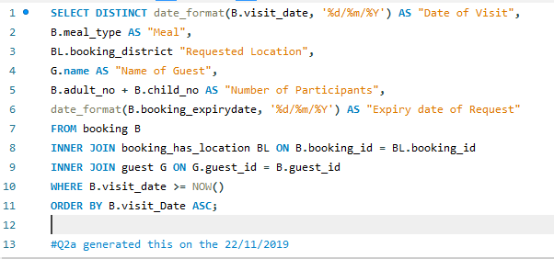

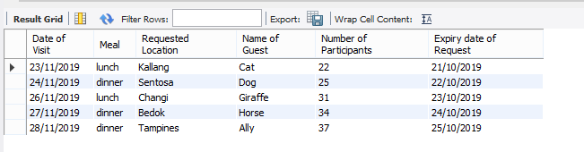

2b

|  |
| --- |
| SELECT BL.booking_district AS "Location", |
| L.region_name AS "Region", |
| Count(S.booking_status) AS "Number of Comfirmed Bookings" |
| FROM booking_has_location BL |
| INNER JOIN status S ON BL.booking_id = S.booking_id |
| INNER JOIN booking B ON B.booking_id = BL.booking_id |
| INNER JOIN location L on BL.location_id = L.location_id |
| WHERE S.booking_status = "Confirmed" |
| AND S.offer_status = "Accepted" |
| AND B.visit_date between "2019-10-01" AND "2019-12-31" |
| GROUP BY BL.booking_district |
| ORDER BY count(S.booking_status) DESC; |
|  |
| #Q2b generated this on the 22/11/2019 |



2c)

|  |
| --- |
| Select H.name "Host Name", |
| HL.host_district AS "District", |
| format(avg(F.host_rating),1) AS "Average Rating", |
| round(sum(HGT.transaction_amount),2) AS "Total Amount Received ($)" |
| FROM host H |
| INNER JOIN host_has_location HL ON H.host_id = HL.host_id |
| INNER JOIN hostguest_has_transaction HGT ON H.host_id = HGT.host_id |
| INNER JOIN feedback F ON H.host_id = F.host_id |
| WHERE YEAR(HGT.date) = 2019 |
| GROUP BY H.name |
| ORDER BY sum(HGT.transaction_amount) DESC; |
|  |
| #Q2c generated this on the 22/11/2019 |



2d)

|  |
| --- |
| SELECT date_format(HGT.date, '%d %M %Y') AS "Date", |
| IF(HGT.transaction_id = 'REVE', concat(concat(upper(left(B.meal_type,1)),substr(B.meal_type,2)),' with ', G.name,' from ',G.nationality), HGT.transaction_desc) AS "Description", |
| HGT.transaction_amount "Amount ($)" |
| FROM hostguest_has_transaction HGT |
| INNER JOIN booking B ON B.booking_id = HGT.booking_id |
| INNER JOIN guest G on G.guest_id = B.guest_id |
| WHERE HGT.host_id = 'stefanie@myrp.com.sg' |
| AND Month(HGT.date) = 10 |
| AND YEAR(HGT.date) = 2019 |
| ORDER BY HGT.date ASC, HGT.transaction_amount DESC; |
|  |
| #Q2d generated this on the 22/11/2019 |

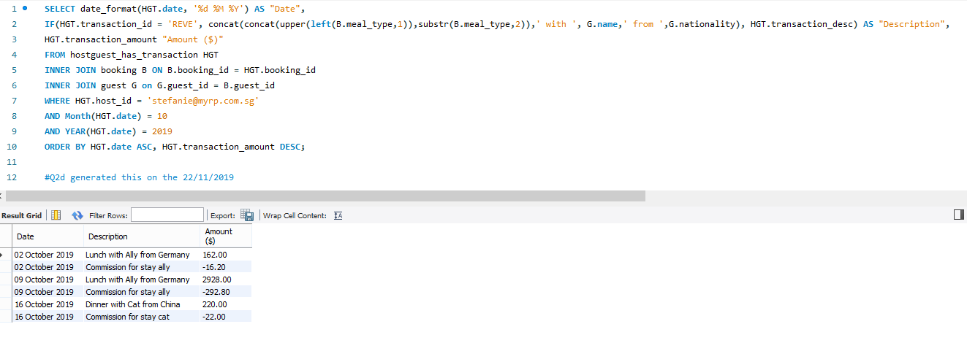

2e)

|  |
| --- |
| SELECT DISTINCT G.Nationality AS "Country", |
| count(S.booking_status) AS "Number of Confirmed Bookings", |
| format(avg(B.adult_no + B.child_no),1) AS "Average Number of Participants Per Visit", |
| max(B.adult_no + B.child_no) AS "Maximum Number of Participants Per Visit", |
| format(B.total_cost,2) AS "Total Amount Collected From Bookings ($)" |
| FROM Guest G |
| INNER JOIN Booking B ON G.guest_id = B.guest_id |
| INNER JOIN Status S ON S.booking_id = B.booking_id |
| WHERE S.booking_status = 'Confirmed' |
| AND year(B.booking_date) = 2019 |
| GROUP BY G.nationality; |
|  |
| #Q2e generated this on the 22/11/2019 |

